## Accessibility iconography

The goal for the requested icons was to research the meaning behind each icon’s representation. The intention was to attempt to keep the visual identity relatively neutral or at least easy to edit for re-use. The requested colour purple has been included from the recent designs from the Communications team, this can be changed in the SVG/.ai files.

Initially the icon library for myMSD (below) was evaluated and where possible partial elements were included to keep a consistency within MSD.



Universal metaphors were used for quick identification, the aim of the designs was for many to quickly interpret correctly and not find offensive. Where possible each icon was kept minimal with lesser focus on secondary or obscure elements.

## Grid

The icons were designed on a **24×24**-pixel grid. Icon shapes were weighted towards the middle area of the grid, reserving the outer 1px margin for visual weighting, and maintaining relative aspect ratios. Designing with the pixel grid helps ensure that icons will not appear fuzzy in production.

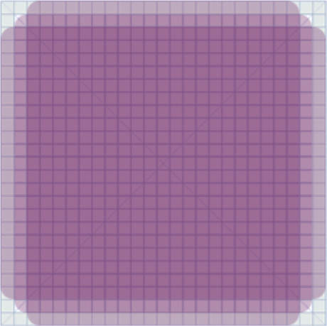

## Shape

Positive and negative space was used to create the icons where the outer border is slightly thicker to maintain enough white space on the smaller internal shapes. Outlined iconography was utilised for usability where the icon style can affect task performance. Task performance was measured by the speed and accuracy of recognising and selecting icons for this project. (ref: [Filled-in vs Outline Icons: The impact of Icon Style on Usability](https://cdr.lib.unc.edu/concern/masters_papers/6w924g35w)).

## File Format

The files are provided in .png and .svg, PNG is provided for fallback or older browsers/Content Management Systems. The SVG’s have been tested and coded based on Accessibility Patterns and used to avoid rasterization. (ref: [deque – Creating Accessible SVG’s](https://www.deque.com/blog/creating-accessible-svgs/)). Although there is no perfect Accessible SVG Icon pattern the closest to serve screen readers and browsers is used. A more descriptive pattern <svg> + role="img" + aria-labelledby="[ID]" + <title> has been included. Naming conventions are kept short as opposed to the longer titles for readability.

## Character

Each design has a personality behind them, as mentioned where feasible myMSD icon stylings were integrated.

### Awareness



This character differs somewhat from myMSD’s person icon to add more shape to the body with the semi-circular shapes around their head representing audible/visual awareness. Limitations to characteristic cues (i.e. face, clothing) is intentional for faster recognition as smaller icon sizes may be difficult to interpret.

### Accommodation



Similar to the housing icon within myMSD with the additional bed icon to represent “a place to sleep”.

### Accessibility



This icon has been used as it is becoming more universally recognized as the ability to access, although the wheelchair icon is used within myMSD for accessibility the latter often represents disability. The focus is to make things accessible to all people.

### Lead programme of work



A minimalistic icon based off the logo present in the lead programme of work page within [msd.govt.nz](https://www.msd.govt.nz/about-msd-and-our-work/work-programmes/lead-programme-work/index.html) to keep consistent with MSD branding. The only addition is the circular border, though kept open ended as an entry point for leadership.

### Who we are (and what we do)

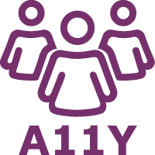

Utilising the original character from ’Awareness’ additional characters are included to represent a team. The A11y is included to identify more than just a team but for what we do within Accessibility, the only caveat here is users may ponder “what does A11Y mean” but may build on curiosity to learn A11y/Accessibility.

### Legislation



The scales of justice are used as the most familiar symbol associated with law/legislation. The additional book represents the legal documentation supported by the bookmark.

### IT Accessibility at MSD

### 

Using the already identified Accessibility icon is to keep design patterns consistent. The style of the accessibility icon ‘overlapping’ the monitor is to emphasise the importance of accessibility within IT as opposed to just placing it on the display. This is particularly relevant if the icon(s) are used at the smallest recommendation of 16x16px.

### Best practice accessibility guidance



Again, the consistency of the Accessibility is apparent, the award/badge is intended to represent that we are achieving Best Practice and rewarded for the work meeting standards.

### News and events



A common attribute for newspapers is used here, similar to IT “accessibility for MSD” the megaphone is overlapping to represent events. In this instance, although this may be misconstrued that events are more important than news its positioned here otherwise the newspaper lines and articles would be too difficult to decipher at 16px by 16px.

### Networks



Once again promoting the A11Y icon in a common network icon, initially the intention was to include icons representing all the senses affected by accessibility but at the smaller size would be too difficult to decipher.

### Who we work with / our partners



Mimicked from myMSD though within an enclosed circle, originally the hands were completing a puzzle but as the image was scaled down this was too difficult to visualise.